|  |  |  |  |  |
| --- | --- | --- | --- | --- |
| **Identify Hazard and Risk** | **Who is at risk?** | **Control measures** | **Consider and describe your control measures** | **What has changed that needs to be thought about and controlled?** |
| **Hazard** – something that may cause harm or damage  **Risk** – the chance of it happening | Eg: young people, leaders, parents, carers, volunteers | **Controls** – ways of making the activity safer by removing or reducing the risk from it. For example you might use a different piece of equipment or you might change the way the activity is carried out. | Describe the actions you will take to control the risk – giving examples | Keep checking throughout the activity in case you need to change it – or even stop the activity. Use this for future reviews |

|  |  |  |  |  |
| --- | --- | --- | --- | --- |
| Preparing risk assessment: lack of ability |  | **Controls could include:** working in buddy system with a leader |  |  |
| Maintain social distance at drop off and pick up: higher risk of infection spread if social distancing not maintained |  | **Controls could include**: clear expectations expressed to all involved, stagger arrival and pick-up. No transport provided by organiser. |  |  |
| Maintaining social distance during meeting: higher risk of infection spread if social distancing not maintained. |  | **Controls could include**: Limit group size in line with current government guidelines and space of meeting. Provide clear guidance on how many leaders and helpers count within group size. Maintain and mark space. Preplan management of groups for each activity. Provide clear guidance for groups. |  |  |
| Hygiene of people: higher risk of infection spread if proper hand washing not carried out |  | **Controls could include**: Provide clear expectations in advance. Provide/require hand sanitisers to be brought to meeting. Sanitise hands on arrival, during and at end of meeting. |  |  |
| Hygiene of toilets: higher risk of infection spread if hygiene not carried out |  | **Controls could include**: check availibility of toilet facilities and cleaning regime. If no toilet facilities plan shortened duration of meeting. |  |  |
| Hygiene of activity equipment: Higher risk of infection spread if hygiene not carried out. |  | **Controls could include**: Cleaning of activity equipment before and after use by each group. Assign specific items to individuals for duration of meeting. Limit equipment used including consumables eg. paper. Individuals bring own equipment for personal use. |  |  |
| Use of outdoor spaces: open area, cannot be cleaned |  | **Controls could include**: Preplan visit to site, choose location suitable for activity. Brief leaders and young people on boundaries. Hand cleaning during activity. |  |  |
| Use of indoor spaces: increased risk of infection |  | **Controls could include:** Preplan layout of assigned indoor area. Brief leaders and young people on clear physical boundaries. Brief leaders and young people on boundaries of interaction with other groups/bubbles. Ventilation of indoor area. Detail hygiene and cleaning responsibility of indoor area between groups. Planning activities not using certain areas eg. Kitchen. Consider duration of meeting. |  |  |
| Use of outdoor spaces unevenground: slips, trips, falls: higher risk of infection spread if offering 1st Aid, lack of social distancing |  | **Controls could include**: choose suitable location for activity. Provide 1st Aid Kit with hygiene measures. Ensure supervision - suitable number in adult/child ratio. Additional hand hygiene measures. |  |  |
| Use of indoor spaces unevenground: slips, trips, falls: higher risk of infection spread if offering 1st Aid, lack of social distancing |  | **Controls could include**: communication with location providor to understand cleaning responsibilities. Provide 1st Aid Kit with hygiene measures. Ensure supervision - suitable number in adult/child ratio. Additional hand hygiene and furniture hygiene measures. |  |  |
| Administering 1st Aid: lack of social distancing, risk of spread of infection |  | **Controls could include:** Add face coverings, aprons, gloves to 1st Aid kit. Self treatment for minor wounds for teenagers and adults. Keep up to date with current Covid-19 government resuscitation advice. |  |  |
| Health of people: higher risk of infection spread if any participants are ill |  | **Controls could include**: Parental written confirmation of health of young person prior to meeting (can be text, email – keep for 6 weeks). Adult volunteer written confirmation of health prior to meeting (written). Register and contact details kept for **all** participants for every meeting (for track and trace requirement). Check government guidelines for face coverings. Update and have to hand register and contact details to parents/carers and all present. |  |  |
| Health of people: outdoor and indoor temperature: risk of infection spreading if sharing items |  | **Controls could include:** expectation to wear clothes/shoes suitable for weather (this may mean not full scout/guide uniform), head wear. Consider facilities for indoor changing from outdoor clothes to uniform. Expectation to provide own water bottles, food refreshment and utensil, sun cream. Check weather forecast prior to activity. |  |  |
| Security of people: risk of getting lost and potentially straying into areas of higher risk of infection |  | **Controls could include:** suitable adult/child ratio. Define boundary. Regular headcount. Each participant provided with contact number to group leader. Communicate to leaders and participants boundaries if other groups are also using the facilities |  |  |
| Security of people: safeguarding children and vulnerable adults |  | **Controls must include:** Adult leaders and volunteers have DBS checks. One off volunteer has suitable Safeguarding declaration. All adhere to principles outlined in “Safeguarding – a code of good practice”. |  |  |
| Suitability of outdoor programme: risk of infection spread if social distancing not maintained |  | **Controls could include**: dialogue and preparation together with leaders and volunteers to ensure suitable activities. Ensure social distancing. Check weather forecast prior to meeting. |  |  |
| Suitability of indoor programme: risk of infection spread indoors if social distancing not maintained |  | **Controls could include**: dialogue and preparation together with leaders and volunteers to ensure suitable indoor activities. Ensure social distancing. |  |  |
| Consider and add other risks and mitigations |  |  |  |  |
|  |  |  |  |  |
|  |  |  |  |  |
|  |  |  |  |  |
|  |  |  |  |  |

|  |  |  |  |
| --- | --- | --- | --- |
| Risk Assessment prepared by | Name:  Role:  Date: | If ‘buddy system’ used to prepare risk assessment provide details of support person designated by line manager. | Name:  Role:  Date: |
| Checked by (Region level) | Name:  Role:  Date: |  |  |
| Approved by (Commission level) | Name:  Role:  Date: |  |  |
|  |  |  |  |

All personal information collected on this form will be processed in accordance with the PSA UK Region Privacy Notice which is available at <http://www.zhpwb.org.uk/okreg-wielko-brytyjski/dokumenty/> The data in this form is used to assess the suitability for the return to face to face Polish Scouting based on the controls put in place.

**Notes on preparing risk assessments**

**All PSA UK Region units must have appropriate Covid secure risk assessments for outdoor and/or indoor activities approved by PSA UK Region risk assessment approvers before they can start face to face activities.** Risk assessments approved before at earlier stages of restarting face to face activities need to be reassessed by the unit leaders but, do not need to be submitted for reapproval by the PSA UK Region approval team. Units which intend to return to face to face activities but, do not have a covid secure risk assessment must prepare and submit one for approval. **Please allow a two week turnaround time from first submission to final approval.**

Risk assessments should now include control measures for both outdoor and indoor activities. If you have provided a risk assessment for indoor activities only, you must remember that you will not have approval for any outdoor activities and vice versa.

It is suggested that the risk assessment (even if prepared in two stages for outdoor and then indoor activities) clearly shows control measures for the two different settings – outdoor and indoor. This can be done within the one document using different colour font for the considerations.

Remember to describe your control measures, giving examples.

Risk assessments are individual to every unit (każda jednostka) irrespective of whether they have meetings in the same place as other units or (within permitted guidance) join the activities of another unit. They should be the independent thought and commitment of the unit leadership team. For those less experienced in preparing risk assessments support in understanding and developing the independent thought should be given by the Regional leadership team. The base line for the risk assessment should be the template provided in the COVID-19 document section of the PSA UK Region website.

‘*Control measures could include*’ are suggestions for control measures. When completing your risk assessment, you can consider these, choose those relevant to your unit and add further ones. At this point you need to remove the wording ‘control measures could include’ as you should be stating your decisions.

If you feel your local situation cannot be managed in a safe way, you should not re-open until you have put sufficient measures in place.

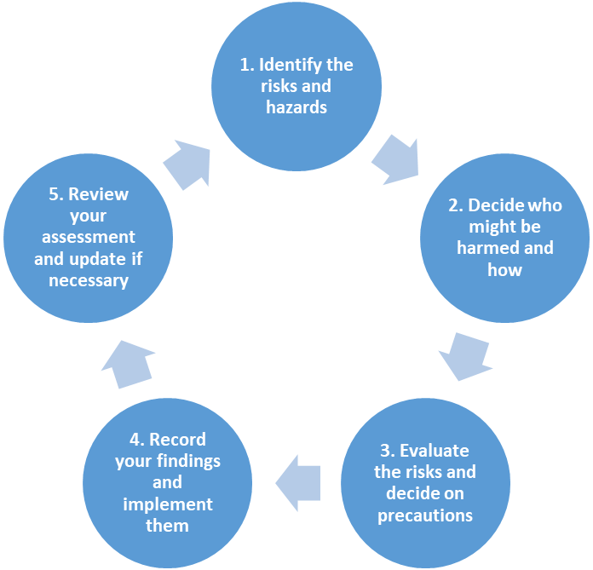

**RISK MANAGEMENT**

**WHAT TO DO**

**HOW**

Look for things that can cause injury or damage, think about the activity, location and surroundings

Think about the people around, not just members, participants and volunteers, who could be affected by the activity

Think about how serious the risk is to injury or property. What is already in place to prevent the injury or damage and does this reduce the risk?

List actions required to reduce risk

Make sure everyone knows what to do and when. Make sure it is done and record it