tarcza Hufca | Związek Harcerstwa Polskiego Okręg w Wielkiej Brytanii  Polish Scouting Association UK Region  Nazwa Hufca | 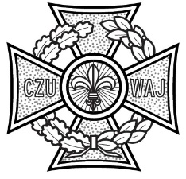

PARENTAL/LEGAL GUARDIAN CONSENT FOR THE ADMINISTRATION OF ADDITIONAL MEDICATION NOT IDENTIFIED ON HEALTH CARD

This form is required when a Parent or Legal Guardian requests that medication not previously identified on the Participants Health Card is administered during an overnight camp. All information must be printed legibly.

Details of Participant requiring additional Medication Administration
Full Name |  | Age
Name of Unit  Nazwa jednostki |  | Camp dates

In addition to the previously agreed list of ‘over the counter’ and other medication identified on my child’s Health Card, I give consent to the following additional medication to be given to my child:

Medication name
Medication dosage
(e.g. 1 tablet; 5mls)
Frequency to be administered  Please tick when to be administered | Morning | Noon | Evening | Night
Reason medication is required

Medication name
Medication dosage
(e.g. 1 tablet; 5mls)
Frequency to be administered  Please tick when to be administered | Morning | Noon | Evening | Night
Reason medication is required

Medication name
Medication dosage
(e.g. 1 tablet; 5mls)
Frequency to be administered  Please tick when to be administered | Morning | Noon | Evening | Night
Reason medication is required

Parent’s/Legal Guardian’s signature__________________________________ Date:___________

Accepted by Camp First Aider – signature_____________________________ Date:___________

The information from this form has to be added to the Medication Administration Chart in the First Aid Log Book (sect 7)

